**Arbitrage Group Establishment**

|  |  |
| --- | --- |
| ****Project number**** | **830892** |
| ****Project acronym**** | **SPARTA** |
| ****Project title**** | **Strategic programs for advanced research and technology in Europe** |
| ****Start date of the project**** | **1st February, 2019** |
| ****Duration**** | **36 months** |
| ****Programme**** | **H2020-SU-ICT-2018-2020** |

|  |  |
| --- | --- |
| ****Responsible organisation**** | **L3CE** |
| ****Editor**** | **Egidija Veršinskiene** |
| ****Dissemination level**** | **Confidential** |
| ****Revision**** |  |

# Disclaimer

The information in this document is provided “as is”, and no guarantee or warranty is given that the information is fit for any particular purpose. The content of this document reflects only the author`s view – the European Commission is not responsible for any use that may be made of the information it contains. The users use the information at their sole risk and liability.

# Table of Contents

Disclaimer 2

Table of Contents 3

Figures 4

Introduction to the Program 5

Umbrella Demo Case 6

Role of the Arbitrage Group 7

Organization of Arbitrage Group Activities 8

Planning and Conducting of Evaluations 8

Provision of Evaluation and Feedback 9

Requirements for Arbitrage Group Members 9

Arbitrage Group Member’s Efforts Remuneration 10

# Figures

Figure 1. T-Shark Governance Model 6

Figure 2. Workflow 8

# Introduction to the Program

The ultimate goal of the T-Shark program is to develop and validate methodological, organizational and technological solutions that will enhance cybersecurity through the comprehensive organization of security functions, focusing on threat prediction and full-spectrum cybersecurity awareness; this will allow for informed decision and policy making at senior levels on broad, long-term issues and provide timely warnings of potential threats, especially top tier threats such an as multi-staged attacks that are uniquely designed, well organised and targeted to the most vulnerable societal functions.

The T-Shark program aims to create an integrated platform that will enable cybersecurity users to carry out effective threat intelligence operations, allowing all stakeholders to work together optimally in a comprehensive manner through:

* Multi-institutional approaches
* Real time information sharing
* High situational awareness
* Exploitation of multi-competence capabilities

The customised solution brings together best-of the breed technologies, people, process and technical architecture enabling to identify, monitor, report and improve threat intelligence operations.

Identifying the need to test and validate the concept of T-Shark platform under the real world conditions, the programme partners came concluded that all technology solutions (sub-cases) should be linked to an “Umbrella “ demo case that would serve as a basis for the structuring the Stage Gates process as enabler for technology testing, evaluation and demonstration exercises.

# Umbrella Demo Case

After much discussions the “Elections Interference” scenario was selected as an “Umbrella” demo case. This scenario covers a broad range of threat categories that may apply for the majority of EU countries and was selected for the purpose of demonstrating the effect and impact of the most promising technology solutions aimed at predicting complex cyber threats before any major damage to the democratic or social process on national or EU level occurs.

Up to sixteen technology solutions (sub-cases) proposed by nineteen partners will be assessed and tested through the Stage-Gates evaluation process, competing against each other in three Challenge areas, in a Contest-like manner. The “Challenges Contest” involves the following thematic areas:

* + “Visual Analytics” (T4.2)
  + “ALL Data based threat intelligence” (T4.3)
  + “Information sharing and integration” (T4.4)

The Stage-Gates process includes a standard sequence of activities to access, validate and progressively increase the quality of technologies, in order to deliver a solution package ready for deployment as exemplified in the model depicted below:

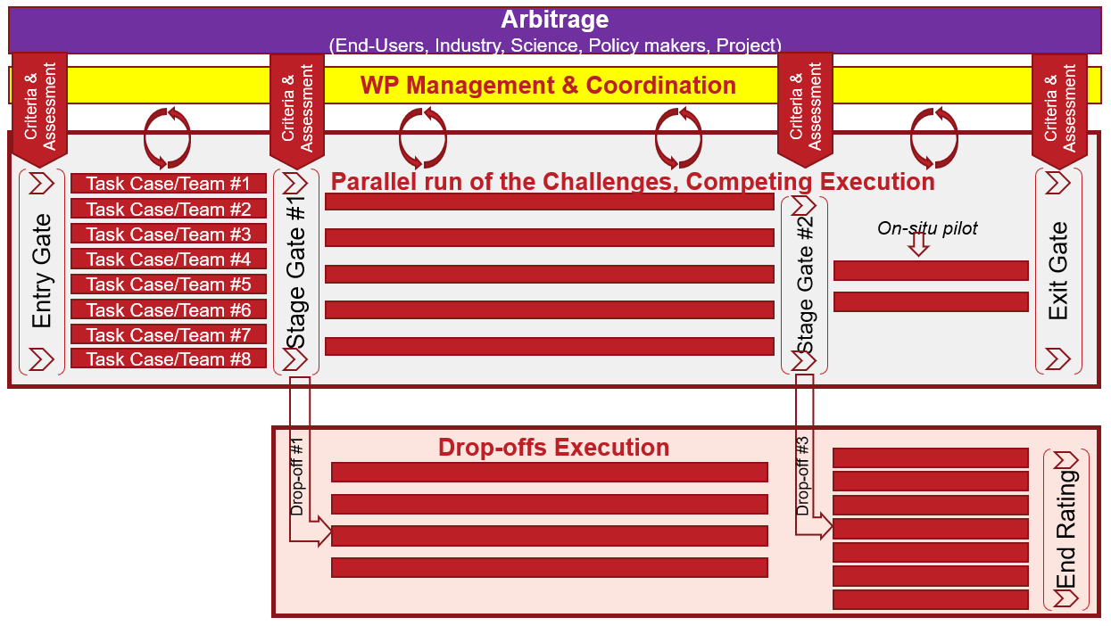

Figure 1. T-Shark Governance Model

The structure of Stage Gates evaluation and monitoring process will be introduced to AG members after establishment of Arbitrage Group.

# Role of the Arbitrage Group

In order to ensure that strategic outcomes and objectives of T-Shark program are tightly linked to end-user priorities and expectations, independent experts in the form of an AG, will be invited to build the assessment process ensuring that only the essential and the most promising technologies are selected.

The Arbitrage Group in the SPARTA T-Shark program is a multi-stakeholder group involving representatives from Industry, Academia, Policy sectors and end-user organizations. Also, independent experts from the SPARTA project will be included in the AG.

It is expected that AG members will play a strategic role in the competition benchmarks, results assessment and testing exercises.

In the beginning, the AG will consist of 15 experts in total, while each stakeholder group is represented by 3 experts. Experts from different stakeholders’ groups will focus on specific aspects of the evaluation process as follows:

* Industry experts on technology: novelty of technology, expected time to market/ deployment, commercialization potential, impact on enhancement of professional services;
* Academia experts on the research and innovation: evolution of state of the art advanced technical and societal solutions, methodological justification, potential for further research;
* Policy experts on regulatory aspects: fit to national and EU regulatory framework and priority areas, legitimacy of application considering privacy and personal data protection;
* End-user experts on suitability: relevance of solutions to current and future challenges, sufficiency of functionality, fit to current practice and operations, potential to adopt the solutions under the development.
* SPARTA project experts on compatibility: quality of management of the development process, compatibility with other research programs.

Over time, additional appointments to the AG may be deemed necessary to strengthen the assessment process.

# Organization of Arbitrage Group Activities

Involvement of AG members in the sub-case evaluation process will help to determine if timely adjustments are needed in the program design or implementation, or quality of achievements relative to the committed goals and objectives. External evaluation will also support the program team with the evidences needed to demonstrate impacts/ results as well as planning the future roadmap once the SPARTA project is completed.

Involvement of AG members can be divided into 3 major activities:

* Planning and conducting T-Shark programme evaluation
* Planning and conducting evaluation of Sub-Cases
* Participation in Showcase events and providing feedback

To ensure that the evaluation process will produce valuable and useful information and considering the fact that AG members have very limited resources for actively contributing to the process, the program team will ensure that full support and assistance to AG members is provided as follows:

* Development of the evaluation plan
* Development of evaluation criteria
* Organization and administration of evaluation events (Showcase events)
* Development and dissemination of supportive materials
* Production of summary reports
* Providing assistance during and post - evaluation exercises

## Planning and Conducting of Evaluations

AG members will be involved in sub-case evaluation on a periodic basis. Referring to the technology description and the Stage-Gates organization plan sub-case demonstrations (Showcase events) will be organised and delivered every 6 months over a 36 months period. Approximately 45 minutes will be allocated to each sub-case demonstration session. AG members will be informed about scheduled meetings at least two weeks in advance.

The workflow is presented in table (below):

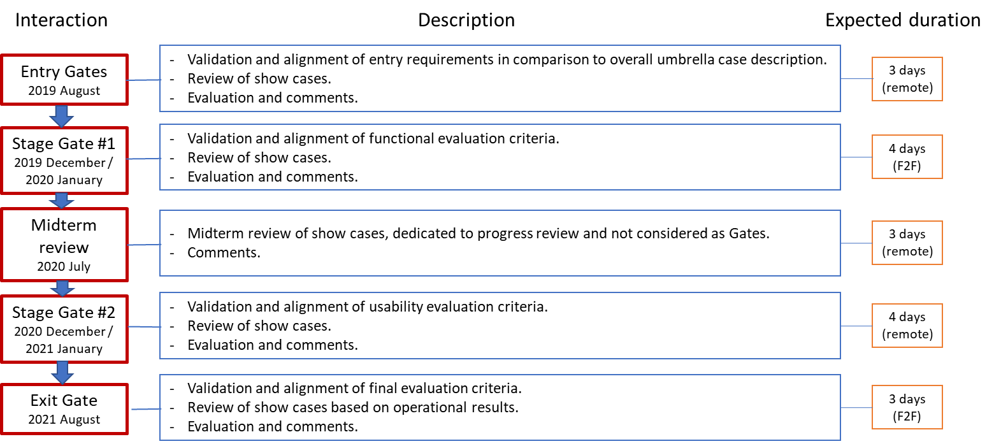

Figure 2. Workflow

Considering the number of sub-cases and variety of demonstration scenarios the Showcase events can be organised in either on-line or on-site form according to an upfront-agreed scenario and implementation plan.

To be sure sub-case providers must ensure that life demonstrations on particular technology solutions will include broad and sweeping approaches that complement the competence areas of Arbitrage Group members, for example, how the solution:

* Solution evolves over the time (Entry Gate – Exit Gate)?
* Fit to the “Umbrella” demo case?
* Is able to exploit the needs of a practical end-user environment
* Can support predictions of estimated time to market?
* Etc.

Live discussions and Q&A sessions will help AG members gain a deeper insight into the nature of the solution, witness how rapidly the new ideas are transformed in to real world solutions and determine the “next-best-alternative” that would have been used in lieu of each selected solution.

## Provision of Evaluation and Feedback

Each expert is expected to provide quantitative and qualitative evaluation of Showcases as presented by T-Shark partners, based on agreed upon criteria, but not limited to these.

All essential content characteristics, findings, comments and recommendations provided by AG members during Showcase exercises will be included in the “Summary Report”.

The T-Shark program team will provide support to AG members particularly with regard to the drafting documents, reports and memos related to all evaluation activities.

AG members will be asked for their feedback on the ideas, concepts and documents related to sub-case evaluation results and the evaluation process.

## Requirements for Arbitrage Group Members

Given the functions and involvement of Arbitrage Group members, the main criteria for selecting members are competence and professional recognition.

The general criteria for selecting Arbitrage Group experts are as follows:

* Availability and willingness of candidates to commit to actively participate in the execution of the Stage-Gates process from start to finish;
* In-depth expertise in one or more areas of concern in the T-Shark program including, for example, technology and social sciences, results assessment, and policy analysis, to mention but a few;
* An established reputation in providing high-level credibility to assessment processes;
* Ability to assess and synthesize technical material rapidly;
* Strong command of the English language;
* Experience in communicating, promoting and incorporating program results to end-users in a real-time operational environment.

Considering the different expert perspectives in the assessment of results, the T-Shark program will certainly provide a comprehensive picture on the relevance, usability and integrity of different technology solutions in relation to the “Elections Interference” use-case. Thus, specific qualities and capabilities looked for in experts are as follows:

* Industry & technology (3 experts): awareness of new cutting-edge technologies, product development cycle, commercialization, enhancement of professional services;
* Academia & science (3 experts, research and innovation): good knowledge of early stage innovation, prototyping, efficiency improvement, new phenomena adoption, relevant research activities, solid publication record;
* Policy & regulatory areas (3 experts): wide experience in dealing with the differing national regulatory, legal and legislative systems of the EU, including strategy development as applied to the formation of new regulatory frameworks, and policy development as applied to legal aspects of cybersecurity; in depth understanding of case law, for example, which cases are relevant and which decisions were seminal in specific topic areas of cybersecurity;
* End-users (3 experts): familiarity with existing practices, gaps, limitations, needs and demands, as well as usability issues generally; wide experience in early adoption of break-through innovations for institutional or organizational operations;
* EC project leadership (3 experts): experience leading multi-million-euro projects, sound project management skills, especially conflict resolution.

Evaluation of members will be made by the T-Shark coordination team, based on expert CVs, and the criteria listed above.

## Arbitrage Group Member’s Efforts Remuneration

AG members do not receive any remuneration for their services except for their traveling expenses. If sub-case evaluation (Showcase) events will be organised on site all travelling and experts accommodation expenses will be compensated from SPATRA T-Shark program budget.