Ethics and Security Social Media 1st Campaign

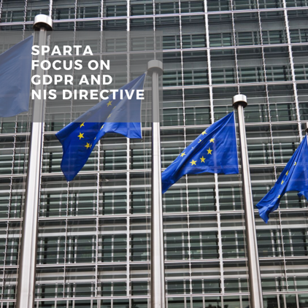

1. Cybersecurity research and innovations can have a sustainable success only if ethical and societal impacts – both short-term and long-term – are assessed and prioritised alongside technical and business impacts.
2. SPARTA addresses major ethical, legal and societal aspects relevant in the context of large-scale cybersecurity research and innovation in a transnational competence network.
3. SPARTA partners commit to conform to an ethical conduct in their research activities.
4. Ethical and legal measures will ensure the pillars of the European Charter of Fundamental Rights - Dignity, Freedom, Equality, Solidarity, Citizens' Rights, and Justice - are protected by the technology developed in SPARTA.
5. SPARTA provides strong security and privacy guaranties with the use of relevant approaches such as privacy-by-design and privacy-by-default, aiming to protect and ensure the values of the European Charter of Fundamental Rights.
6. Concerning the legal framework, we focus on relevant EU-level legislation, in particular the General Data Protection Regulation and the Directive on Security of Network and Information Systems.